Floating cities, life on Mars and colossal egos: inside the battle of the billionaire blokes in space.

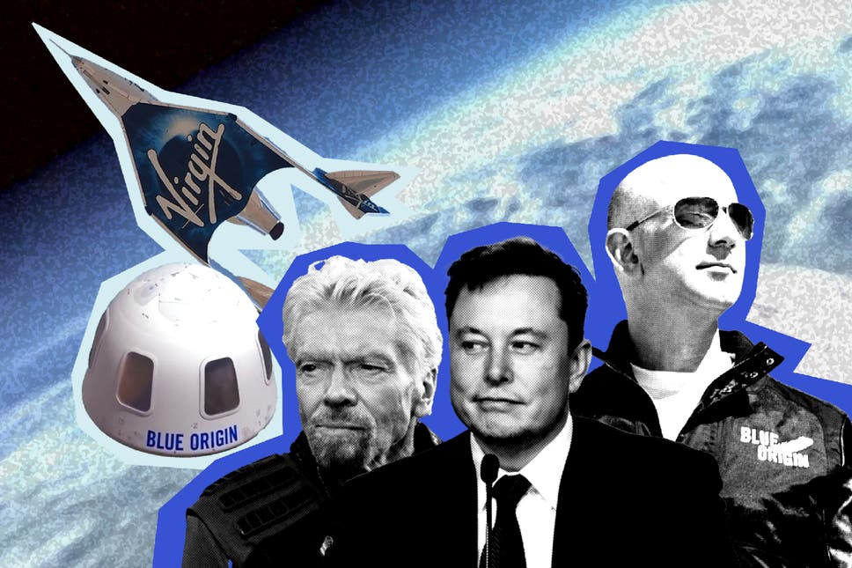
The billionaire space race is hotting up. But these boys and their (rocketship) toys are just getting started, says Samuel Fishwick
1. Jeffrey Bezos, you did it. Yesterday the planet’s richest person became space’s wealthiest tourist, blasting off in his New Shepard capsule — a spunky, workmanlike hunk of metal described on Twitter as a “gumdrop-shaped capsule” and a “dong rocket” — 52 years to the day that Neil Armstrong placed his boots on the moon.

2. “Best. Day. Ever”, said Bezos, after his 11-minute trip to the edge of space. Bezos, his brother Mark, 82-year-old aeronautics legend Wally Funk and 18-year-old Oliver Daemen — the youngest and oldest people to go to space respectively — made it back to West Texas in one piece.

3. Indeed, the billionaire space race is hotting up. Last week, Richard Branson’s big shiny space Virgin Galactic rocket plane made it 53.4 miles up to the edge of space. With five colleagues, the 70-year-old soared above the Earth on VSS Unity. “Welcome to the dawn of a new space age,” Branson said. “It’s been the experience of a lifetime... I’ve dreamed of this moment since I was a kid but honestly, nothing can prepare you for the view of Earth from space. It’s just magical.”
Branson’s space crusade came nine days before Bezos blasted off on the first crewed flight by his rocket company, Blue Origin. Not to be outdone by Branson — merely the world’s 589th richest

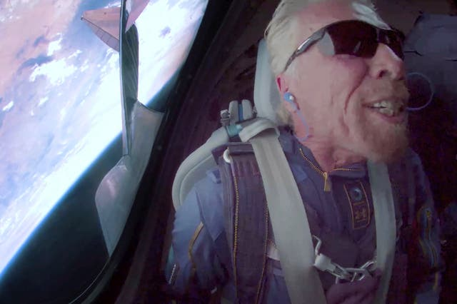
person — Bezos went up more

than ten miles higher, just past

the internationally recognized

Karman Line — but was only

there for four minutes.
4. If you think this won’t be a point of contention between adult CEOs with the power of space flight at their cheque-writing fingertips, think again. “Jeff who?”, Branson replied, when asked if he was trying to pip Bezos to the punch.

5. Mileage, minutes, and clicks are big factors in the space spat — every space billionaire needs a vast online audience watching his live streams, after all. Slick websites keep legions of Earthbound fans in the loop. In June, Bezos announced his trip to one million people via an Instagram video. “Ever since I was five years old, I’ve dreamed of travelling to space.” In the video, Bezos, wearing a cowboy hat and aviators, drink in hand, walks up to his younger brother Mark and says, “I really want you to come to space with me”. Chances are you might have helped him achieve his dream: “I want to thank every Amazon employee, and every Amazon customer, because you guys paid for all this.”

6. Their crew were joined by Daemen, the son of millionaire Dutch businessmen (a mystery bidder who spent $28 million on a ticket pulled out with “scheduling conflicts” and will go later, leaving a seat open for Daemen), and Funk, the veteran US pilot, 82, who was one of the most promising female candidates for the Mercury 13 programme, before NASA closed it in 1962. In an Instagram video, the Amazon founder asked Funk how she would feel to leave the planet. She threw her arms around him and squealed: “I would say, ‘Honey, that was the best thing that ever happened to me!’” If The Breakfast Club had the brain, the jock, the basket case, the princess, and the criminal, this Blue Origin flight has the boss, the tag-along, the real deal, and the kid, says The Atlantic’s Marina Koren.

7. But this billionaire space race is not just a click measuring contest. Great leaps forward are being made. The best work to date has been done by Elon Musk’s Space X. His craft are unusual in that they are reusable, and reliably so. On April 16 Nasa awarded him $2.9bn to develop a lunar lander as part of America’s plan to return astronauts to the Moon by 2024. Bezos, who plans to step down as Amazon CEO this summer to devote more time to space, was reportedly “livid”. His bid to fly Nasa to the moon was spurned. Musk poked fun by pointing out that, unlike SpaceX, Blue Origin has made only suborbital flights so far, tweeting: “Can’t get it up (to orbit) lol.”

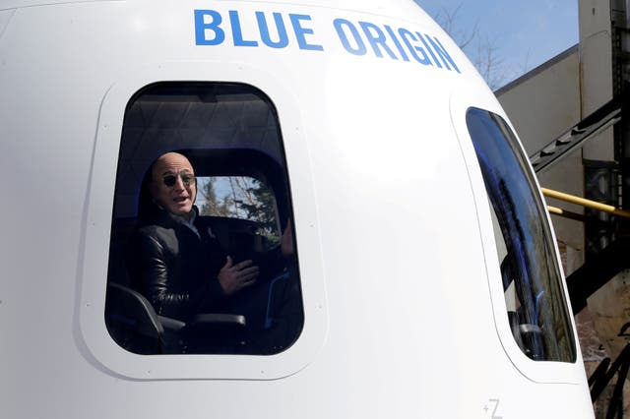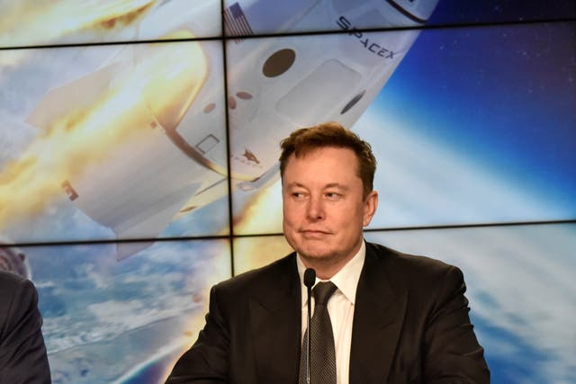

8. The Tesla boss, 50, is also making real money. Nifty Falcon 9 rockets already ferry other company’s satellites up to orbit regularly for $62 million a pop. His own Starlink satellite chains will be the biggest satellite network ever, beaming fast internet access to every corner of the planet. The punchier Dragon rocket has ferried crews of up to seven up to the International Space Station, and there are plans to take non-astronauts to the moon by the end of the year. But Dragon is only half the size of Starship, Musk’s jewel in the Space X crown — the vehicle he expects to take man to Mars. A super-heavy, spectacularly silver prototype successfully roared 10km into the Texas sky in May and landed, for once, without blowing up. Despite its vast size, it is fully reusable, and is intended to be far cheaper than SpaceX’s current rockets. Musk hopes Starship could end up costing less than $2 million per launch.

9. But for now, the headlines belong to a gurning Branson, and Bezos — the first billionaires to boldly float weightlessly where no billionaires have floated weightlessly before. Viewers at home even imagined Bezos’s ex-wife Mackenzie Scott was pleased: “Hard to imagine a better divorce outcome than getting 50 billion dollars and then your ex literally leaves the planet”, tweeted one. But here’s looking at you, rich kids.

Adapted from: https://www.standard.co.uk/insider/richard-branson-space-virgin-galactic-jeff-bezos-b945337.html

